Goals:

1. Explain what cities can expect *after* they post a policy online
2. Identify common commenters by group (civic tech/academia/etc.)
3. Identify popular “sticking points”, i.e. things that residents care about
   1. Most popular sections, most popular comments, number of comments
   2. Sentiment analysis
   3. Popular authors’

**Analyzing Online Collaborative Policy Making as a Tool for**

**Community Engagement**

Crowdlaw for open data policy is [an approach for collaborative policy drafting](https://docs.google.com/document/d/10LKN0s9M0JhNFaAFuZzfd32cUQYcPKvaogriTzN4zgc/edit?usp=sharing) between residents and city governments. It gives residents an opportunity to provide online feedback on policies, which helps cities build better relationships with residents and get real insight into how open data will affect residents’ lives.

Over time, we have helped several cities use crowdlaw to develop their open data policies, and compiled a [Crowdlaw Tracker](https://docs.google.com/spreadsheets/d/10pOyaJRtKCpvNk3IZFLmVZEeNZJ4yaeaku2Ax7oL68g/edit#gid=0) to catalog their experiences. In our [Intro to Crowdlaw](https://docs.google.com/document/d/10LKN0s9M0JhNFaAFuZzfd32cUQYcPKvaogriTzN4zgc/edit?usp=sharing) memo we detailed how crowdlaw can be used to craft an open data policy, and explored a case study on Pittsburgh’s efforts to implement crowdlaw through data user groups and tools such as Google Docs. This memo is written to highlight the lessons and takeaways from the public engagement on crowdlaw.

For this explainer, we analyzed cities that have used [Madison](https://opengovfoundation.org/projects/madison-project/) to post their open data policies online for feedback from the public. Those cities are Buffalo, Durham, Tyler, Glendale, Nashville, Syracuse, Naperville, the BART system and San Francisco. While anlayzing cities, we looked at some of the most popular policy sections based on number of comments made by users, policy sections that received most positive, neutral or negative public comment, and characteristics such as the professional backgrounds of the users who comment.

**How does the the community participate in open data crowdlaw?**

***Level of engagement based on total comments***

The cities of Buffalo, Syracuse, and Naperville had the highest levels of community engagement when they posted their policy online. Buffalo, in particular, saw increased participation after city staff [conducted a targeted outreach](https://sunlightfoundation.com/2017/03/23/how-opening-data-and-policy-to-the-public-online-can-make-both-better/) to find potential users of its open data policy and actively sought their feedback in the development of city’s open data policy. On the other hand, BART, Durham and San Francisco received only a handful of comments. These cities have had open data policies well in place for some time, and were found to be well developed and overall satisfactory. 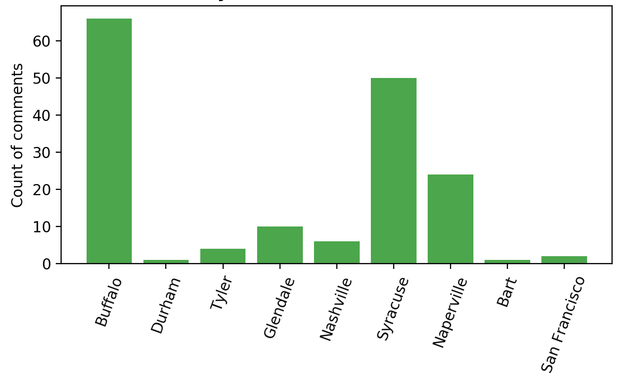

It is, therefore, important for cities that are applying crowdlaw concepts in drafting their open data policies to use different methods to galvanize public participation, instead of just making the policy online and waiting for residents to comment. Like Buffalo, cities will be well served by identifying potential users of open data and directly seeking their participation. Tools like social media and other forms of direct communication will also be helpful in generating participation.

***Level of engagement based on popular policies***

When cities understand which policy sections are most popular, it can help them anticipate how people will react to different sections of their open data policy. Cities can use this information, ahead of time, to prepare materials and answers to effectively engage with the community. In our analysis, popular policy sections are those that have been quoted by different people two times or more.

A number of people expressed questions on the ability of open data to handle private and sensitive information **(City of Syracuse and City of Buffalo)**, and appreciated the role that Open Data Governance Committees can play to solicit feedback and ideas from residents **(City of Naperville).** 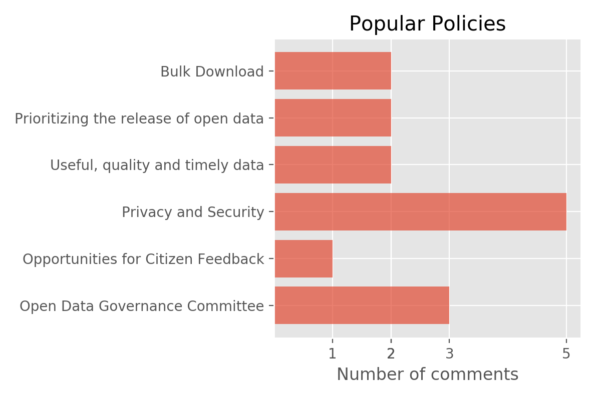

The comments also show that users don’t only question or appreciate the policy but also encourage additional changes where necessary. For example, in the following example, the user expressed that he would like the datasets to be made more interactive and customer-friendly, instead of only existing in a high quality format.



While the suggestions asking for governments to provide opportunities for more community feedback were few, they were highly “liked” or “replied to” by other people.

We consider comments to be popular if they have been ”liked” or “replied to” (by other people) three times or more. Comments were most popular in the cities of Buffalo, Naperville and Syracuse given the higher levels of community engagement in these cities. 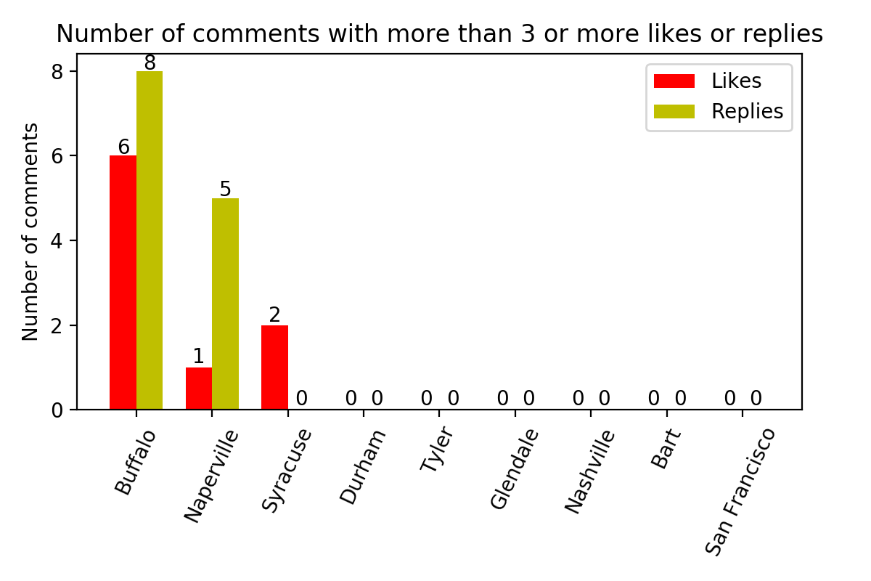

Some other highly liked or replied to comments were regarding tools to make data easily accessible and useful by creating metadata **(Joseph Gosen, Buffalo)** or presenting data in a range of formats such as xml, shapefile etc. **(Karyn Tareen, CEO, Geocove - Buffalo).**

Most of these popular comments tend to come from users who have found open data portals difficult to navigate, access or use, or those who find the efforts to solicit feedback from residents insufficient.

***Residents’ “emotional” reaction to open data policy***

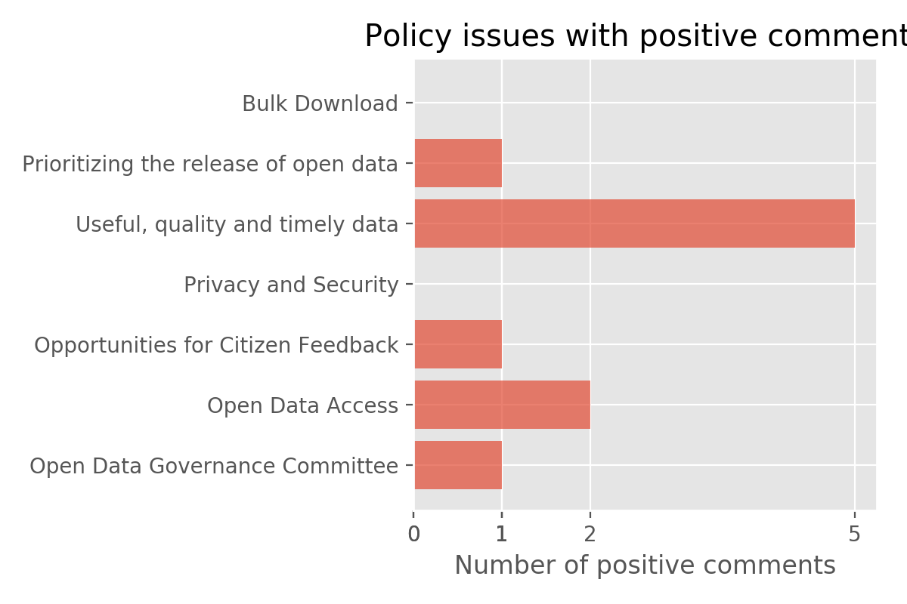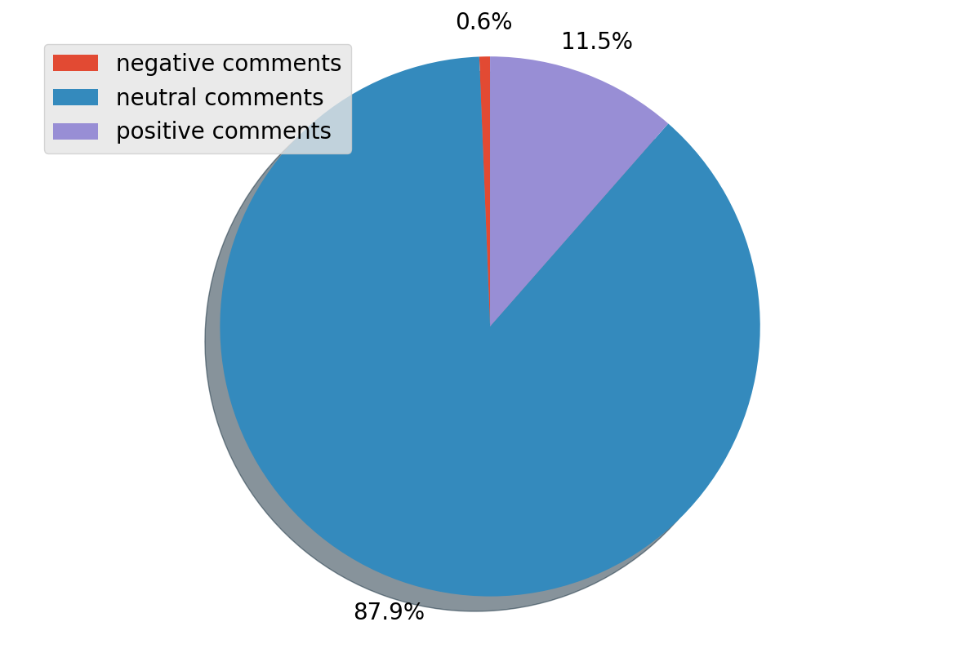

About 88% of comments were either questions to understand policy better or suggestions for improvements to different policy sections. In general, people were curious to learn more about how confidential data will be handled, how the FOIA requests will be processed and whether they will be made available in a timely manner, and potential for community organizations and academic institutions to host data on open data portals.

Many people also made suggestions. Aaron Krolikowski, a researcher, on the *“Privacy and Security”* section of Buffalo’s Open Data Policy, said:



Furthermore, a handful of users also expressed joy. For example, Jurnell Cochren, a software developer, was delighted to see that the City of Nashville provided a Data Catalog for all its datasets so that users can understand and explore the datasets easily.

An example of a less favorable comment was one regarding the City of Buffalo’s policy on releasing private information. That comment stated that the city should take into account “risks to the public” before making any data public.

**Understanding the user segments of crowdlaw can help cities expand the open data reach**

Out of 65 public users from the nine Madison websites we analyzed, 27 of them belong to the “Unknown” category, meaning we weren’t able to locate their professional details online. Of those we’re able to identify, a majority of them belong to private organizations such as tech start-ups. A handful of them are affiliated with academia, public and not-for-profit sectors. The various profiles of these users demonstrate that people from diverse professional backgrounds are active participants in the development of open data policy.

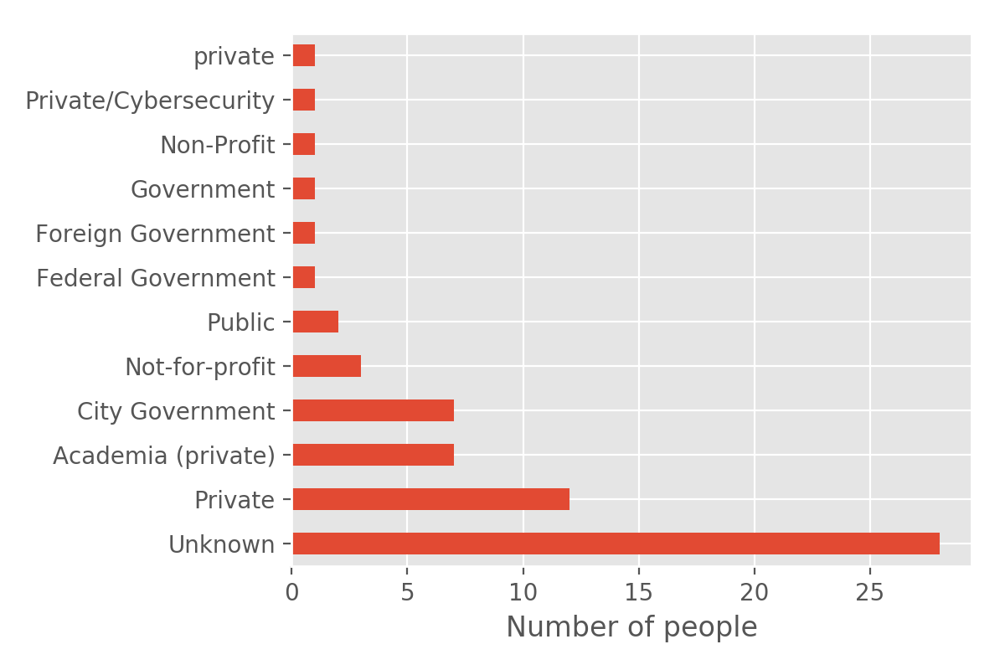

Furthermore, most of the people in categories other than “Unknown” had a technical background, in the sense that they worked in technical jobs in the government or were part of private tech companies. In Syracuse and Buffalo, both the technical and non-technical audience, has enthusiastically participated in crowdlaw. This is mainly due to the city's efforts to mobilize community members through social media and on-the-ground [surveys](https://docs.google.com/document/d/1tewPPwVD6BBXLx9eYf4YwgpX3HEMS3PaQZRRUzPfcq8/edit).

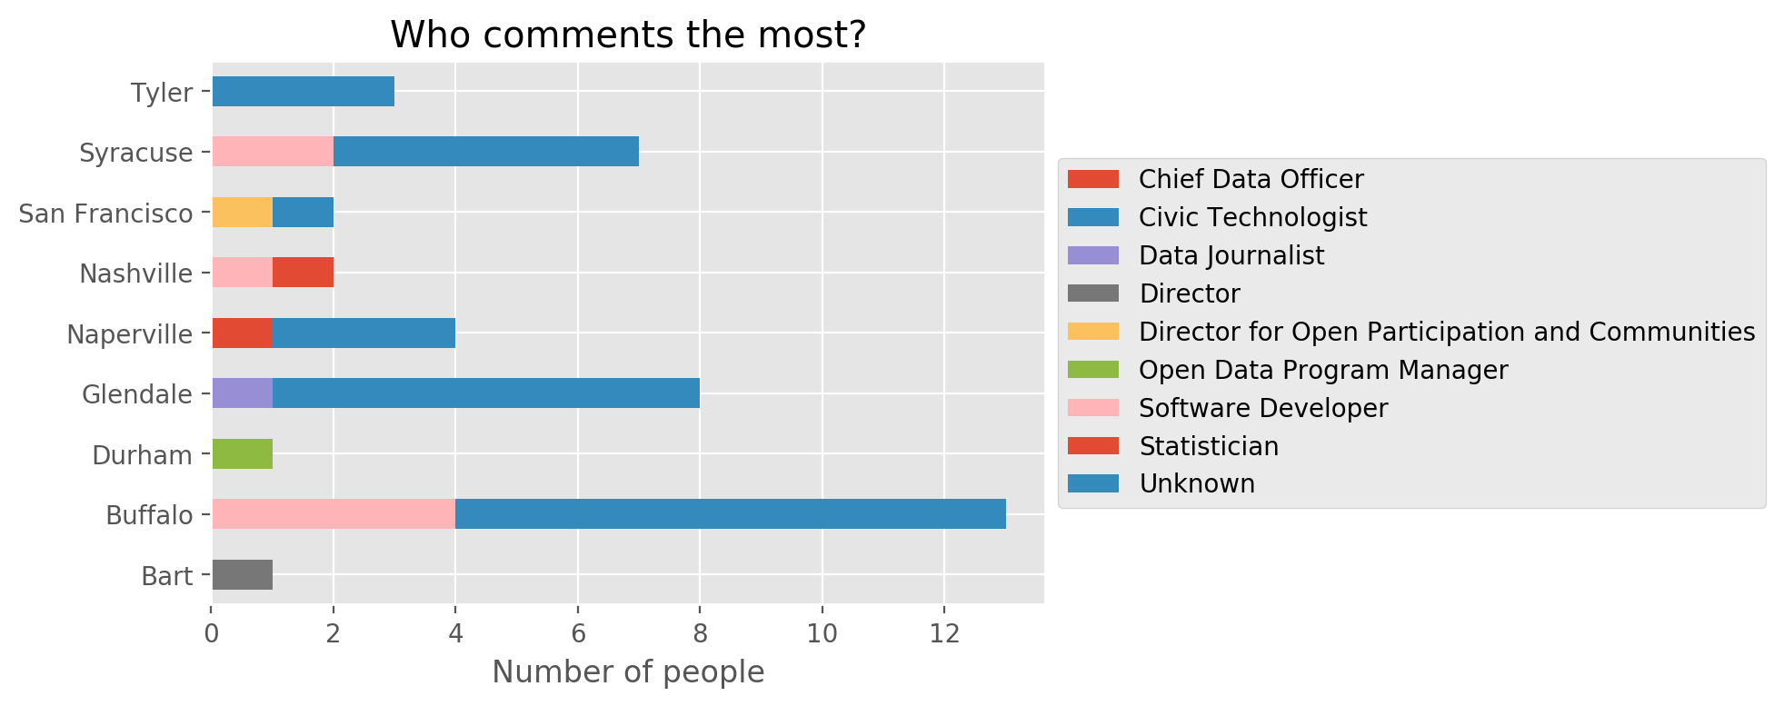

Similarly, Arlington should seek multiple avenues to reach out to as many residents as possible. This will help the city incorporate public ideas and suggestions in its open data policy before it is enacted, instead of waiting for a problem to surface later on. When the crowdlaw practice is conducted carefully - by soliciting feedback from public, properly following up, re-writing policy drafts, and evaluating the impact after the policy is enacted - it can greatly strengthen ties between residents and the government.